Funding Cycle
Spring
Fall
Winter
Grant/Report
Renewal
Final Report

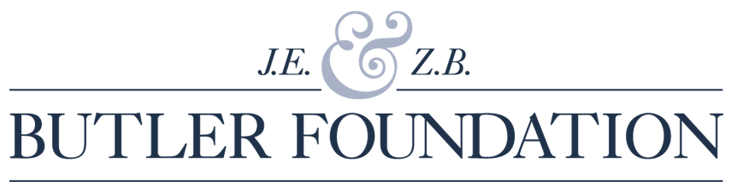
Phone: 917 301-9421
www.butlerfoundation.org

ANNUAL REPORT and RENEWAL

Name of Organization _______________________________________________________________
Address______________________________________City____________ State_________Zip_______
Executive Director ____________________Phone__________ E-Mail__________________________

Name of Program _________________________________Target Population ___________________
Program Contact __________________________________Title _____________________________ Phone_________________________ E-Mail_______________________________________________

BUDGET INFORMATION | Total Agency Budget | Program Budget | Butler Foundation Grant | Program Dates
2021 Grant |  |  |  | __/__/__-__/__/__
2022 Grant Request |  |  |  | __/__/__-__/__/__

% of Funding | Government | Foundation/  Corporation | Individuals | Endowment | Program Fees/Earned Revenue | Board Contribution
Agency
Program

TARGET POPULATION
Program Participation | Total Unduplicated | M | F |  | Pre-school | 5-12 | 13-21 | 22-39 | 40-64 | 65 +
2021 Anticipated # to be served
2021
Actual # served
2022 If renewal included, anticipated # to be served

PROGRAM SCHEDULE (Please check which apply to your program)
After School | Year Round | Summer | Vacation | Other  Please Describe

PROGRAM RETENTION
Name of Program | Hours per session | Sessions per week /month | # participants who started program | # participants who finished program | Reasons for non-completion

In light of the Foundation’s focus on disabilities and our desire to raise awareness of meaningful inclusion of people with disabilities in the larger community, please answer the following:

- Does your organization include people with disabilities on its board and staff, and among those you serve?

- If applicable, describe your efforts to increase the organization’s capacity to effectively serve and employ individuals with disabilities
Have there been any significant changes in organizational structure or leadership since the beginning of the grant period?
Other Funders (foundations, government etc):
Previous Butler Funding (include programs & # of years funded):

Narrative: No longer than 5 pages Times New Roman 12 pt.

Annual Report

- General Agency Overview
- What is the overall health of your agency?
- What do you anticipate will be the good and bad lasting impacts of Covid-19 on your agency as whole, and on your budget in particular?
- If your agency receives government funding, did you get any new contracts or experience any cuts in your government contracts/grants? What is the outlook going forward?

- Butler Funding
- What have you been able to accomplish with this year’s funding?
- Did you experience any roadblocks this year and if so, how did you get around them?
- Describe your efforts to engage participants and their families?
- During the past year, did you collaborate with other organizations?
- What are you most proud of this year?
- How might lessons learned over the past year, impact future program delivery and funding?

- Going forward: Please discuss next steps and what data or other information you will use to determine future programming. List three program goals and objectives that you want to accomplish in the coming year. How will they be implemented, assessed, and measured for effectiveness?

- Key Staff: Describe roles, qualifications, education, and experience of key staff involved in this project.

Financial Accounting and Sustainability: What favorable or unfavorable conditions occurred during this grant period that impacted your program budget? Describe efforts you are making to secure additional revenue to support this program. Is there a possibility that this program will ever be eligible for government funding or other institutional funding?

- Budget Report: Please use the Annual Report/Renewal budget form found under “Forms” on www.butlerfoundation.org Please remember to account for any unused funds from the 2020 budget in your 2021 budget.

- Additional Required Supporting Materials
- Most recent Audited Financials
- List of Board of Directors
- Annual Report
- Program materials (no more than 3 examples)

